**首届全国大学生类脑计算创新应用大赛  
暨国际邀请赛**

**技术文档**

队伍编号: 0178

项目名称: 自然语言处理系统

选题范畴:

Sentiment analysis for typeface recommendation

呈现载体: Powerpoint

所在高校: Singapore University of Technology and Design

团队成员:

Chan Luo Qi

Hong Pengfei

Hum Qing Ze

**摘 要 (Abstract)**

Artificial intelligence (AI) has been around for decades and exploded recently due to the advancements in machine learning algorithms, available big data, and the exponential growth of computing power with decreased cost. Till now near-human performances have been demonstrated in multiple domains, such as computer vision, speech recognition, and natural language processing (NLP).

AI systems are used to analyse and understand information collected by finding patterns from data. Our team explores AI comprehension through the field of NLP which is becoming increasingly empirical and quantitative in their approaches by applying different algorithms and probabilistic models to be able to predict the semantics of a given text. Support Vector Machines (SVM) in particular have been shown to be highly effective at traditional text categorisations. However, current NLP researches are focusing on understanding texts by analysing relationships between words. No work has been conducted on studying the relationship between the semantics of the text and typographical choice.

The advent of the internet has led to the digitisation of typography, previously a hand-crafted art. The mass digitisation of documents leads to a greater standardisation of typefaces and the usage of typography as an aesthetic and mode of communication. Currently, most typographical recommendation systems available to people who need guidance in choosing a typeface are not data-driven decisions but textbooks. In this work, we will implement machine learning algorithms to study different innate characteristics of typefaces, and explore the correlation between typeface design and the meaning it is meant to convey. As there are no prior references, we have gathered our own dataset through publicly available information, applying classification techniques to map the font to a word vector before generating a typeface suited for new corpus of texts. The preliminary data-gathering has revealed a pattern between the mission statement of companies and the typeface chosen in their style guide. To further improve the reliability of our recommendation system, we will utilise a font vector map to allow for greater variation of typefaces recommended beyond our dataset.

This work, which has been overlooked by traditional NLP techniques, may greatly enhance the discovery of semantic meaning in text and create a novel typeface recommendation system. It has potential to develop a multimodal NLP system that takes into account a greater variety of features beyond analysing only the words within text, drawing inspiration from other multimodal neural networks used for audio-visual recognition that has shown substantial increases in accuracy.

**关键词 (Keywords)：**

Natural Language Processing, Support Vector Machines, Text categorisation, Typography, Typeface recommendation system, Multimodal NLP system

**目 录 (Outline)**

1 选题背景 5

2 创新点 6

3 核心技术 7

3.1 问题描述 7

3.2 解决方案 8

3.2.1 Dataset 8

3.2.2 Typeface Classification 9

3.2.3 Font Generation 9

3.3 结果展示 9

4 总结 10

5 未来展望 10

5.1 技术展望 10

5.2 应用展望 11

6 团队介绍 11

7 附录（选） 13

8 References 13

# 选题背景

Artificial Intelligence (AI) can be characterised as the “software and hardware designed to function appropriately and with foresight in its operating environment”. As AI starts to drive progress in society, the field is shifting from “simply building systems that are intelligent to building intelligent systems that are human-aware and trustworthy” [1].

AI has the potential to overcome the “physical limitations of capital and labour and open new sources of value and growth” [2]. Much of AI has been developed over the past 70 years by computer scientists but has only recently become commercialised due to progress in computing power, data availability and the designing of efficient algorithms.

With the recent hype in AI, it is crucial to no longer see it merely as a productivity enhancer but as a tool that can transform our thinking about how growth is created. AI enables a suite of mainstream technologies that are having a substantial impact on everyday lives and can be grouped into 3 broad categories:

1. Sensing

AI technologies have created computer vision and audio processing modules that can now actively allow machines to perceive the world around them. A key application is facial recognition which could be used in the security of hardened facilities as an automatic identification tool.

1. Action

Through expert systems and inference engines, AI can be used to guide our machines in the physical world. An example would be the growing field of self-driving vehicles. which combine machine vision and active detection of the environment to control vehicles safely in real-life traffic conditions.

1. Comprehension

AI systems have been used to analyse and understand information collected by finding patterns in data. An example would be Natural Language Processing (NLP) achieved by applying machine learning techniques to text and speech processing.

Our team explores AI comprehension through the application of NLP as it is quickly becoming a commodity for analysing widely spoken languages due to the availability of large data sets. Research has shifted to developing refined and capable systems that can interact with people through dialog and not just react to stylised requests.

Computational approaches to language research in the 1980s focused on automating the analysis of the linguistic structure of language and developing basic technologies such as machine translation, speech recognition and speech synthesis [3]. Today, the field has moved on to mining social media for information and identifying sentiment and emotion toward products and services.  A popular example would be mining publicly available movie review datasets for sentiment classification to develop recommendation systems [4].

This is possible through the ability of AI to identify parts of speech, recognise entities within a sentence and discover basic semantic dependencies between words. These techniques have allowed AI to create text summaries, discover the sentiment expressed by the text and predict and assess the effectiveness of marketing campaigns.

There are several approaches to NLP. The initial goal of NLP was to extract basic facts such as the relation between two entities [3]. The field is becoming more empirical and quantitative in their approaches by applying different algorithms and probabilistic models. Currently, popular techniques are the Naive Bayes, maximum entropy and Support Vector Machines (SVM).

1. Naive Bayes has been used for relative frequency estimation however it assumes independence between the probability of each word token which does not hold in real life.
2. Maximum entropy has been shown to outperform naive Bayes as their feature function makes no assumptions about the relationships between features relying on feature-weight parameters to act as indicators instead.
3. **SVMs have been shown to be highly effective at traditional text categorisations**. They are large-margin classifiers whose procedure is to find a hyperplane that separates document vectors in one class from those in others with the largest margin possible.

We will be exploring the concept of mining data from a corpus of text for meaning and developing our own recommendation system. [5] Currently NLP is done on three levels:

1. Morphological processing

By studying word structure and comparing words in a text separately to try identifying the classes they belong to.

1. Syntactical processing

This is carried out by transforming a linear sequence of tokens (individual words or punctuation marks) into a hierarchical syntax tree.

1. Semantic processing

The method is used to understand the meaning of the text to develop question-answering systems, translation or populating a base of knowledge. There is typically a need to complete morphological and syntactical analysis before analysing the semantics of the text.

# 创新点

Currently, the researches on NLP are focusing on understanding texts by analysing relationships between words. However, we have noticed that there might be other sources of meaning that is not inherent in the three classes mentioned above. Till now no work has been conducted on studying the relationship between the semantics of the text and typographical choice. Therefore, in this work, we will implement machine learning algorithms to study different innate characteristics of typefaces and the meaning it is meant to convey. We aim to **explore text typography as a source of meaning** **by studying the correlation between textual intent and typographical choice**.

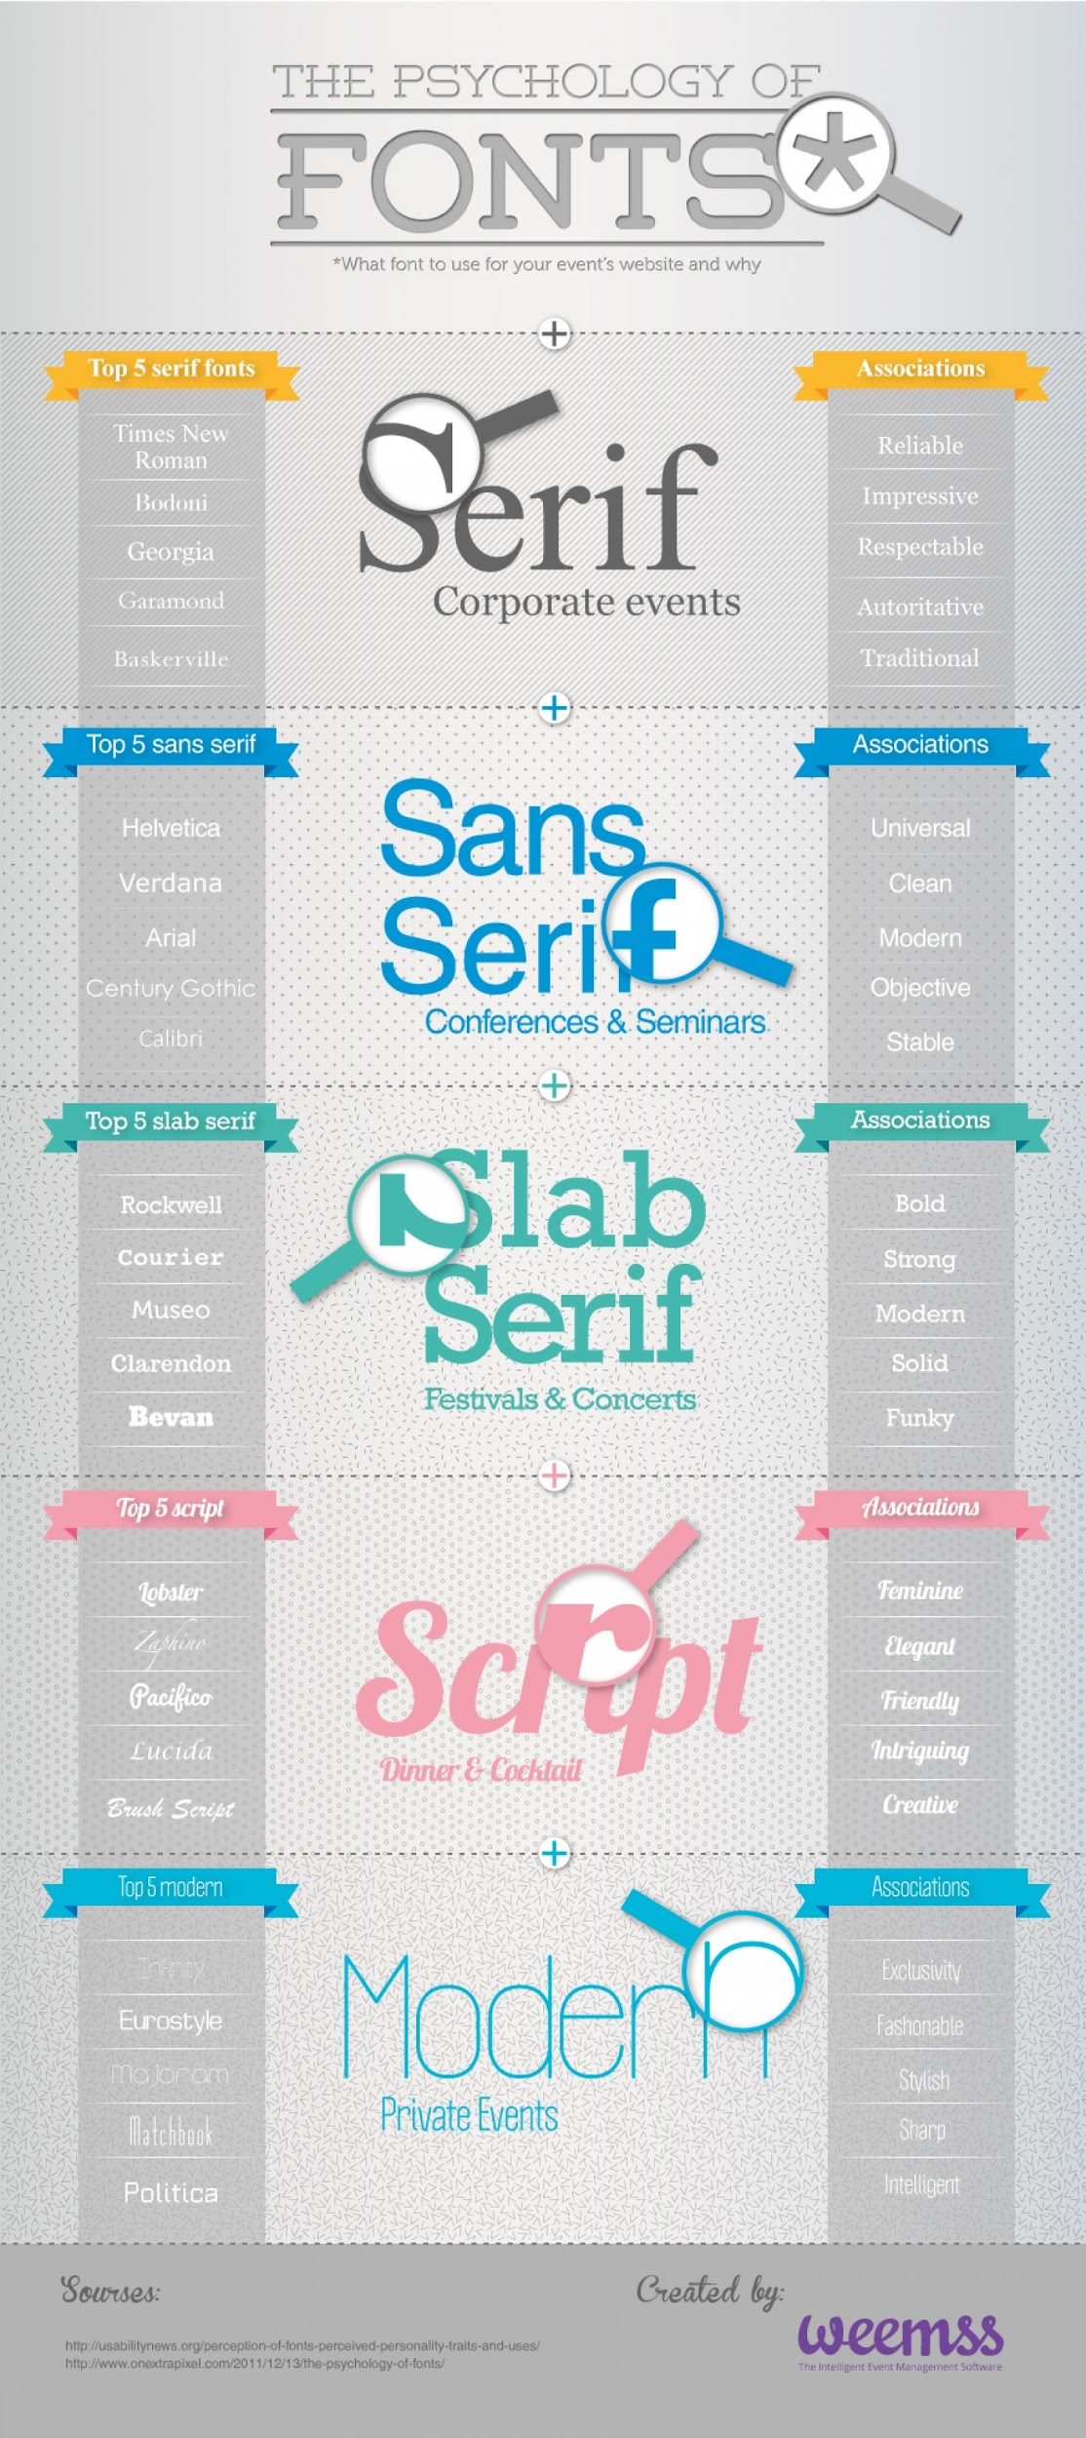

Fig. 1 Examples of psychology of fonts. Taken from “The Psychology of Fonts, what font to use for your website and why”, retrieved from https://visual.ly/community/infographic/business/psychology-fonts

Applying machine learning (ML) techniques to sentiment classification is an aspect that we are exploring. A prominent technique would be Yoon Kim’s use of a Convolutional Neural Network (CNN) for sentence classification by having one layer of convolution on pre-trained word vectors produced by word2vec. [6]. Another method of carrying out data mining on text would be classifying the semantic orientation of individual words or phrases using linguistic heuristics or a pre-selected set of seed words [7]. These techniques are attempts to find features within the text to derive meaning.

Typography has generally been overlooked as a source of meaning by AI research due to its many variations resulting in great difficulty creating a generalised descriptive framework for different types of typefaces. As a result, it is hard to formulate general rules to describe typography as each typeface is created to be unique. This is compounded as the initial problems typography was meant to solve was to improve the legibility of text rather than the semantics conveyed thus people did not intuitively analyse the meaning typography might convey. That has changed recently as the mass digitisation of our documents that have led to greater standardisation of typefaces and the usage of typography as an aesthetic and mode of communication.

It is timely to adopt this approach as the advent of the internet has led to the digitisation of typography and the mass usage of different typefaces [8]. A typeface is defined as a digital font, a piece of computer software that contains a collection of vector ‘drawings’ along with spacing and kerning data that could be accessed through the keyboard. A typeface family consists of many variant fonts that share a common design.

This work, which has been overlooked by traditional NLP techniques, may greatly enhance the discovery of semantic meaning in text and create a novel typeface recommendation system. It has potential to develop a multimodal NLP system that takes into account a greater variety of features beyond analysing only the words within text, drawing inspiration from other multimodal neural networks used for audio-visual recognition that has shown substantial increases in accuracy.

# 核心技术

## 问题描述

In recent years, an entire design consultancy practice has sprung up on recommending and developing style guides for companies. An example would be IBM’s corporate style guide [9] which explicitly lays out typographic guidelines and the rationale behind choosing each typeface. These consultants typically recommend fonts for web design, marketing paraphernalia or even official documents. These fonts are recommended in a font hierarchy for different document segments and classes including font pairing. However, these style guides are highly subjective and unique to each company.

Most recommendation systems available to the people who need guidance in choosing a typeface are in the form of blog posts by designers who share their expertise. These are not data-driven decisions and heavily relied on designers’ experiences. However, when one studies typography closely, typography textbooks and research suggests that **a pattern emerges in the different innate characteristic of typefaces and their recommended use, suggesting a correlation between typeface design and the meaning it is meant to convey.**

This inference is supported by recent papers on typographic meaning. Firstly, the idea of the printed word containing two levels of meaning, that of the word image and the idea of the word itself, suggests that we can mine text for a correlation between typography and semantics [10]. It is also suggested that contemporary typography can create meaning with colour, 3D effects, material texture and even kinetic movement, further displaying the potential of typefaces as a rich but unexplored source of meaning [11]. Font as a mode of communication and a potentially meaningful aspect of written language is now being explored to express ideational and interpersonal meaning potentials as well. Furthermore, available guides on how features of typefaces might be used to express specific semantics, such as fonts with heavy weights being used to make one feel that a corpus of text is more masculine provide a subjective interpretation of the use of typography.

|  |  |
| --- | --- |
|  | Archive black: bold, rounded, meant for impact appropriate for male-directed audience    Archive narrow: lighter condensed style |
| Fig. 2 Example of font recommendation available publicly. Taken from “The Ultimate Guide to Font Pairing” retrieved from https://designschool.canva.com/blog/the-ultimate-guide-to-font-pairing/ | |

Thus, we conjecture **that there is an unexplored resource overlooked by traditional NLP techniques that might greatly enhance the discovery of semantic meaning in text.** We aim to demonstrate this by creating a font recommendation system based on mining data from companies who have an official typeface and available mission statement as most design consultancies recommend a typeface according to the image the company wishes to represent.

**Challenges**

As this is a relatively unexplored field of research, our team faced multiple challenges due to the lack of prior preliminary studies. Firstly, we have to mine and build our own datasets using publicly available data; no suitable previous datasets were available. Secondly, as a result of the lack of data sets, there is no benchmark like there are for Convolutional Neural Networks (MNIST Handwriting Recognition, CIFAR-10) and for Recurrent Neural Networks (Penn Tree Bank). This will demand that a stronger analysis be used to evaluate the effectiveness of the classifier. Thirdly, we had to choose a suitable classification model. Each text classification model is suited for very specific uses, such as emotion or semantic classification and was not usable for our needs. Lastly, the challenge would be to create a large enough font vector map. Font vector maps have only been recently created and used to generate generic fonts without a specific purpose so far.

## 解决方案

To tackle these challenges, we will develop this system by **gathering our own dataset through publicly available information, applying classification techniques to map the font to a word vector before generating a typeface suited for new corpus of texts.**

**3.2.1 Dataset**

We began by gathering our own dataset through publicly available information, which would be matching the chosen typeface of different institution's style guides with their mission statements. We have chosen 9 major typefaces to gather information on as many institutions use these typefaces in their style guide. The dataset will match the typeface with the company’s mission statement. By analysing the semantics of the company’s mission statement, we will attempt to derive a classification of typefaces with a general mission statement word vector.

**3.2.2 Typeface classification**

We will use the LIBLINEAR text classification model as it is highly efficient. LIBLINEAR is the winner of ICML 2008 large-scale learning challenge (linear SVM track). They have managed to develop LIBLINEAR is to solve an unconstrained minimisation problem using novel and effective techniques to adjust the trust-region size for the classifier [12]. It can perform multi-class classification on our dataset and will assign a unique identification number to each instance within our dataset. Then for each entry, it will add the different instances of the words according to its identification number and generate the different weights of the words. This will form a unique vector that maps the font based on the mission statement data.

**3.2.3 Font Generation**

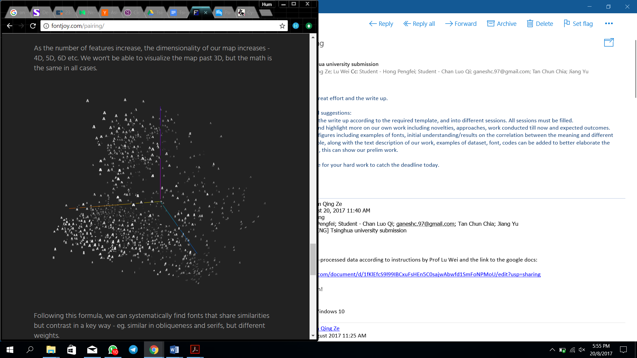To generate a style guide, we will need to run corpus of texts through the prediction engine provided by LIBLINEAR. However, it is unlikely that any test text will fall exactly into one of the 9 categories as intent of each text will tend to vary. Thus, in order to enhance reliability of our recommendations, we propose to have a larger number of font vectors in order to recommend a larger variety of fonts.

Inspired by *fontjoy*, a typeface feature extraction project by Jack Qiao, we will apply a convolutional neural network on different fonts to be able to generate a vector font map. The *fontjoy* vector map is based off similar work from the *OverFeat* network which was trained to solve recognition problems [13]. As we have only come up with a unique vector for these 9 fonts, there is a high chance that when the recommendation model encounters a new corpus of texts it will not be able to fall into an exact vector when processed. Therefore, it is important to generate a font map to create subtle variations in our font recommendations for greater reliability.

Fig.3 Font vector map. Taken from “fontjoy”, retrieved from http://fontjoy.com

## 结果展示

We began by gathering our own dataset which would be matching the chosen typeface of different institution's style guides with their mission statements. We have created a word token dictionary consisting of the unique words within our datasets before pre-processing our dataset into a format that can be utilised by the LIBLINEAR SVM classifier. After training the SVM classifier to generate weights and a word vector based on the classification, we will create a prediction model based on the weights of the prediction vector and the font vectors they correspond to. Thereafter we will use our test set to choose a font vector based on the output vector. This will require further iteration as we test the efficacy of our recommendation system.

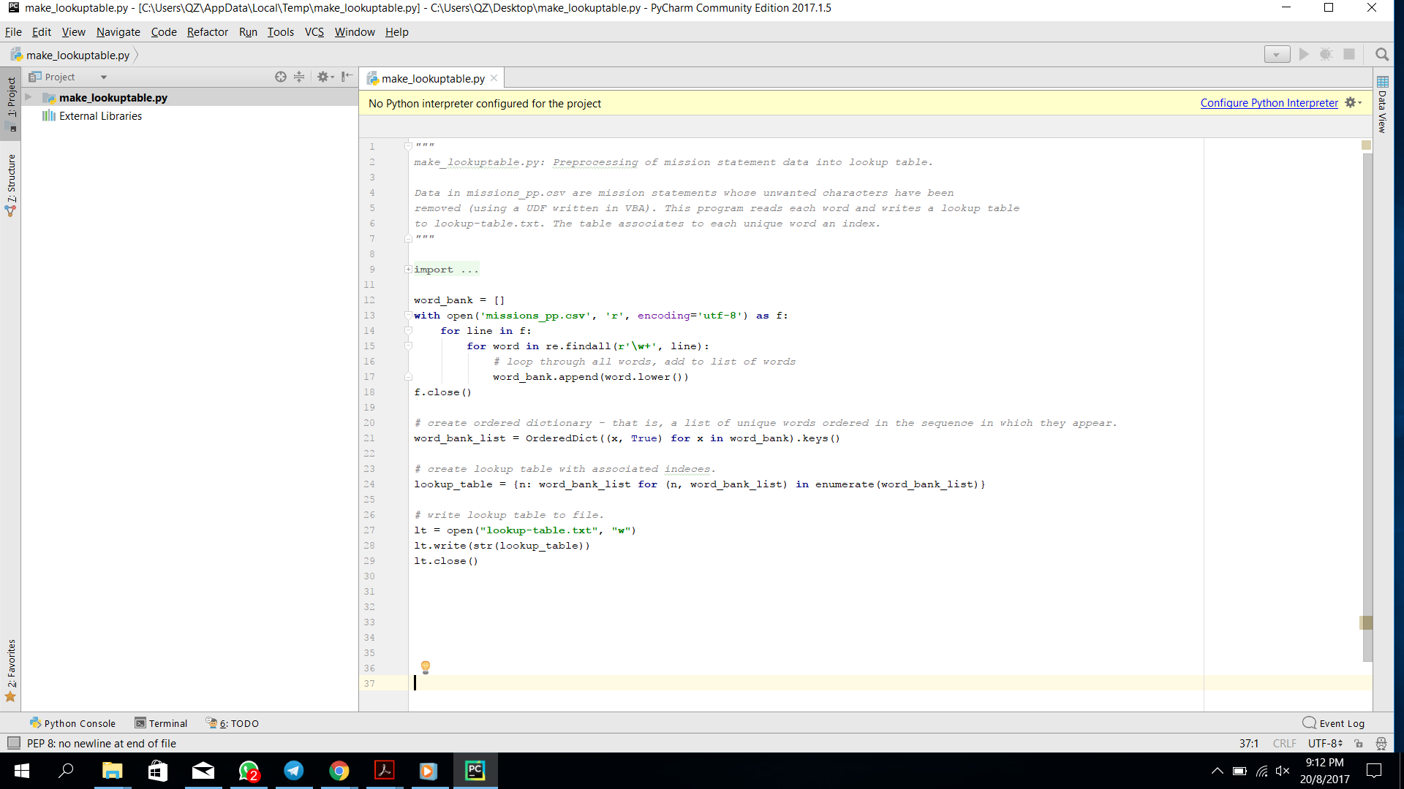Fig. 4 illustrates a code developed for data pre-processing and Fig. 5 shows one example of the pre-processed data.

# Fig. 4 Example of a code for data pre-processing

{0: 'mission', 1: 'values', 2: 'we', 3: 'believe', 4: 'that', 5: 'are', 6: 'on', 7: 'the', 8: 'face', 9: 'of', 10: 'earth', 11: 'to', 12: 'make', 13: 'great', 14: 'products', 15: 'and', 16: 'thats', 17: 'not', 18: 'changing', 19: 'constantly', 20: 'focusing', 21: 'innovating', 22: 'in', 23: 'simple', 24: 'complex', 25: 'need', 26: 'own', 27: 'control', 28: 'primary', 29: 'technologies', 30: 'behind', 31: 'participate', 32: 'only', 33: 'markets', 34: 'where', 35: 'can', 36: 'a', 37: 'significant', 38: 'contribution', 39: 'saying', 40: 'no', 41: 'thousands', 42: 'projects', 43: 'so', 44: 'really', 45: 'focus', 46: 'few', 47: 'truly', 48: 'important', 49: 'meaningful', 50: 'us', 51: 'deep', 52: 'collaboration',...

Fig.5 Example of the pre-processed data

Our preliminary data-gathering has revealed a pattern between the mission statement of companies and the typeface chosen in their style guide. It was found that companies that are more public-facing tend to use Helvetica, which was specifically designed for readability at both long and short distances (Fig. 6). Thus, these companies have adopted Helvetica as their main typography as it represents the spirit of their company and has a practical purpose when creating publications.

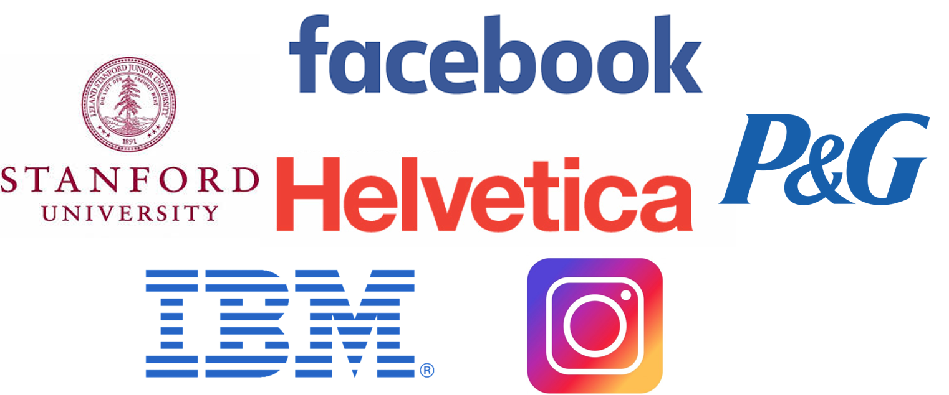

Fig. 6 Companies using Helvetica as a typeface

*Fontjoy* has already demonstrated that one can create a font vector map with their *fontprojector* application; however, it is used for a limited number of fonts.

# 总结

In this work, we implement machine learning algorithms to study different innate characteristics of typefaces, and explore the correlation between typeface design and the meaning it is meant to convey. As there are no prior references, we have gathered our own dataset through publicly available information, applying classification techniques to map the font to a word vector before generating a typeface suited for new corpus of texts. Currently we are in the midst of processing our data-set in order to perform text categorisation. As we are developing our own data-set we are simultaneously exploring a variety of text categorisation techniques and algorithms. The preliminary data-gathering has revealed a pattern between the mission statement of companies and the typeface chosen in their style guide. To further improve the reliability of our recommendation system, we will utilise a font vector map to allow for greater variation of typefaces recommended beyond our dataset.

This data-set can be further mined by more advanced text categorisation techniques once developed to discover even more accurate methods of deriving meaning from typographical choice. The results of our categorisation might serve as a precursor to the enhancing the discovery of semantic meaning in text and create a novel typeface recommendation system. This work has the potential to develop a multimodal NLP system that considers a greater variety of features resulting in a higher semantic prediction accuracy.

# 未来展望

## 技术展望

Our work will be a preliminary proof of concept establishing typography as a source of meaning. Due to our current limitation of dataset, which focuses primarily on companies, we would need to research further on other forms of typographic uses. For example, there is potential to utilise typography to establish context of texts by exploring typography throughout history. We could mine posters or government publicity campaigns to establish a higher fidelity representation of typographic meaning. An example of the government designing unique typefaces for context is *ParaType*, which was created the font department of the Soviet state research institute *Polygraphmash*. *ParaType* designs were based off a Cyrillic typeface which was inspired by the modernist and constructivist movement in Germany. The spirit of modernism and constructivism was chosen as they represented the values that the Soviet Union wished to embody. Figure 7 illustrates an example of a typeface created by *ParaType* would be *Geometric Slabserif*.

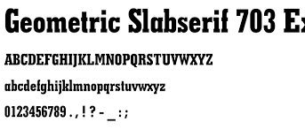

Fig. 7 Geometric Slabserif typeface example

While we were searching for our dataset, we realised that there were existing repositories of fonts such as dafont.com, fontlibrary.org and google fonts which provide a library of thousands of fonts that are free-to-use. Further work would be to mine these libraries for a denser and more extensive font vector map for even more reliable font recommendations.

## 应用展望

NLP focuses on mining the sample text itself for data. A review of current NLP techniques concluded that supervised learning approaches have better results. However most of these systems use features based on a shallow analysis on the text thus it was proposed to have a new direction focused on deep analysis. [14]. There is potential to explore further using multimodal neural networks to conduct deeper analysis on text beyond word tokens to establish greater context for better semantic analysis. Several researchers have shown that a multimodal neural network architecture can create better predictions from a greater diversity of features. More accurate results have been obtained by combining lexical and machine learning techniques to classify emotions in text according to Ekman’s six emotional categories. [15]. This is further supported by research on combining audio and visual recognition deep learning networks resulting in a higher accuracy of predictions on audio-visual classification of isolated letters and digits [16].

Drawing on the inspiration of similar work, we could incorporate a larger scale semantic prediction neural network by incorporating a multimodal architecture, mining not just typography but other sources of contextual meaning that could be tagged to a text such as its history or author.

# 团队介绍

The team consists three first-year undergraduate students from Singapore University of Technology and Design, Chan Luo Qi, Hong Pengfei and Hum Qing Ze. Their roles in this work are described in the following:

Chan Luo Qi:

(1) Data mining and preprocessing: pairing up of mission and vision statement and each font on the official website of companies.

(2) finding the correct neural network suitable for processing texts of mission and vision statement.

Hong Pengfei:

(1) Coding and train the liblinear neural network.

(2) Result demonstration.

Hum Qing Ze:

(1) Lead the idea and scope formalization.

(2) Artistic analysis and proof of the work.

(3) Application of work

The team would like to express their deep appreciation to Ganesh Chandrasekaran from University of Maryland, College Park, Maryland, United States of America, regarding the active technical discussions on machine learning algorithms. The team would also like to greatly appreciate Professors Lu Wei, Tan Chun Chia, Jiang Yu, Lim Kian Guan and Zhao Rong for their valuable technical guidance, support and encouragement.

# 附录（选）

# References

1. Stanford University. (2016) Artificial Intelligence and Life in 2030

2. Purdy, M. (2016) Why Artificial Intelligence is the Future of Growth, Accenture

3. Hirschberg, J and Manning, C. (2016) Advances in NLP, Retrieved from [http://science.sciencemag.org](http://science.sciencemag.org/) on May 12, 2016

4. Timmaraju, A and Khanna, V. (2015) Sentiment Analysis on Movie Review, Stanford University

5. Poroshin, V.A. (2004) Semantic Analysis of NLP

6. Kim, Y. (2014) Convolutional Neural Networks for Sentence Classification, Association for Computational Linguistics

7. Pang, B , Lee, L and Vaithyanathan, S. (2002) Sentiment Classification using ML techniques, Cornell University and IBM Almaden Research  
Center

8. Tam, K. (2006) Digital typography: a primer

9. IBM. (2010) IBM Global Fonts Typographic Guidelines

10. Van Leuwen, T. (2005) Typographic meaning, Cardiff University

11. Serafini, F and Clausen, J. (2012) Typography as a semiotic resource, Arizona State University

12. R.-E. Fan, K.-W. Chang, C.-J. Hsieh, X.-R. Wang, and C.-J. Lin. [LIBLINEAR: A library for large linear  
classification](https://www.csie.ntu.edu.tw/~cjlin/papers/liblinear.pdf) [Journal of Machine Learning Research](http://www.jmlr.org/) 9(2008), 1871-1874.

13. Razavian,A, Azizpou, H, Sullivan, J and Carlsson, S (2014) CNN Features off-the-shelf: an Astounding Baseline for Recognition, KTH Royal Institute of Technology

14. Jain, Y and Sandhu, A (2015) Review on Emotion Detection from Text using Machine Learning Techniques, International Journal of Current Engineering and Technology

15. Gievska, S, Koroveshovski, K and Chavdarova, T. (2014) A Hybrid Approach for Emotion Detection in Support of affective interaction, IEEE International Conference on Data Mining Workshop

16. Ngiam, J, Khosla, A, Kim, M, Nam, J, Lee, H and Ng, A.(2011)Multimodal neural network, Stanford University